HD­ Set Top Box

Specification

**DocumentRecord**

|  |  |
| --- | --- |
| DOCUMENT NUMBER | CONFIDENTIALITY LEVEL |
| GOYA-GX3113E-20200831 | **HIGH** |
| DOCUMENT VERSION | **TOTAL 10** |
| V1.0 |

CONTENT

1 Production Introduction 4

1.1 Scope 4

1.2 Abbreviations and Acronyms 4

2 Software General Features 5

3Hardware Specification 5

3.1 Chipset 5

3.2 Tuner 5

3.3 Demodulator 6

3.4 Video Decode 6

3.5 Audio Decode 6

3.6 Front Panel 7

3.7 Back Panel 7

3.8 Remote Control 8

4 Power supply 9

5 Environment 9

6 Mechanical Features 9

7 Packing 9

8 Accessories 10

# 1 Production Introduction

## 1.1 Scope

The GOYA HD Set-top Box (STB) offers subscribers the latest enhancements in cable television viewing. This STB gives consumers a rich experience with new features which provides customize design solution and a variety of applications such as 7 days EPG, genres navigators and many other utility services.

The GOYA HD STB compliant with DVB-C standards and MPEG-2/MPEG-4. It supports PAL formats with its CAS, it is built to support renewable security. The main features of this STB described as below:

* Integration GOYA solution
* Video decoder support MPEG-2/MPEG-4, H.264, HEVC
* Audio decoder support MPEG-1, MPEG-2 (Layer I & II), AAC
* BIS certification - IS13252 (Part-1):2010

## 1.2 Abbreviations and Acronyms

|  |  |
| --- | --- |
| Items | Description |
| STB | Set Top Box |
| EPG | Electronic Program Guide |
| DDR | Double Data Rate |
| HD | High Definition |
| OSD | On Screen Display |
| RAM | Random Access Memory |
| RF | Radio Frequency |
| DVB | Digital Video Broadcasting |
| SD | Standard Definition |
| CA | Conditional Access |
| LED | Light-emitting Diode |
| PAL | Phase Alteration Line |
| CVBS | Composite Video Blanking Signal |
| IR | Infra-Red |
| MPEG | Moving Pictures Expert Group MPEG |
| QAM | Quadrature Amplitude Modulation |
| MP@ML | MPEG Main Profile at Main Level |

# 2 Software General Features

|  |  |
| --- | --- |
| Items | Features |
| CA Type | Cardless |
| CA system | Sumavision |
| Language | English |
| PAL/NTSC | PAL/NTSC |
| Video Mode | 4:3/ 16:9 |
| Display Mode | Pan /Scan/Letterbox |
| Audio Track | Stereo/Mix/Left/Right |
| EPG | 7 days*24 hours Electronic Program Guide (EPG) |
| Parental Rating | Support Channel Control |
| SW Upgrade | OTA |

# 3Hardware Specification

## 3.1 Chipset

|  |  |
| --- | --- |
| Items | Features |
| Main Chipset | GX3113E |
| Maximum performance | 600MHz |
| SDRAM Memory | 128MByte |
| Flash Memory | 8MByte |

## 3.2 Tuner

|  |  |
| --- | --- |
| Items | Features |
| Frequency Range | 47~862MHz |
| Channel bandwidth | 8MHz |
| Input Impedance | 75Ω |
| Input Level Range | 40dBuV to 95dBuV (typical for 64QAM) |
| Signal input | IEC 60169-24 F-Type, Female |

## 3.3 Demodulator

|  |  |
| --- | --- |
| Items | Features |
| Demodulator IC | Embedded in Main Chipset |
| Demodulation | 16,32,64,128,256 QAM |

## 3.4 Video Decode

|  |  |
| --- | --- |
| Items | Features |
| Video Decode | MPEG-2 MP@HL, MPEG-4 SP and ASP video decoding, H.264 BP/MP/HP, H.265 BP/MP/HP |
| Aspect Ratio | 4:3, 16:9 |
| Video Resolution | Up to 1080p |
| Video Format | PAL/NTSC |

## 3.5 Audio Decode

|  |  |
| --- | --- |
| Items | Features |
| Audio Decode | MPEG-1 I/II , MP3, AAC & HE-AAC |
| Output | Stereo/Mix/Right/Left |
| Sampling Frequency | 32KHz, 44.1KHz, 48KH |

## 3.6 Front Panel

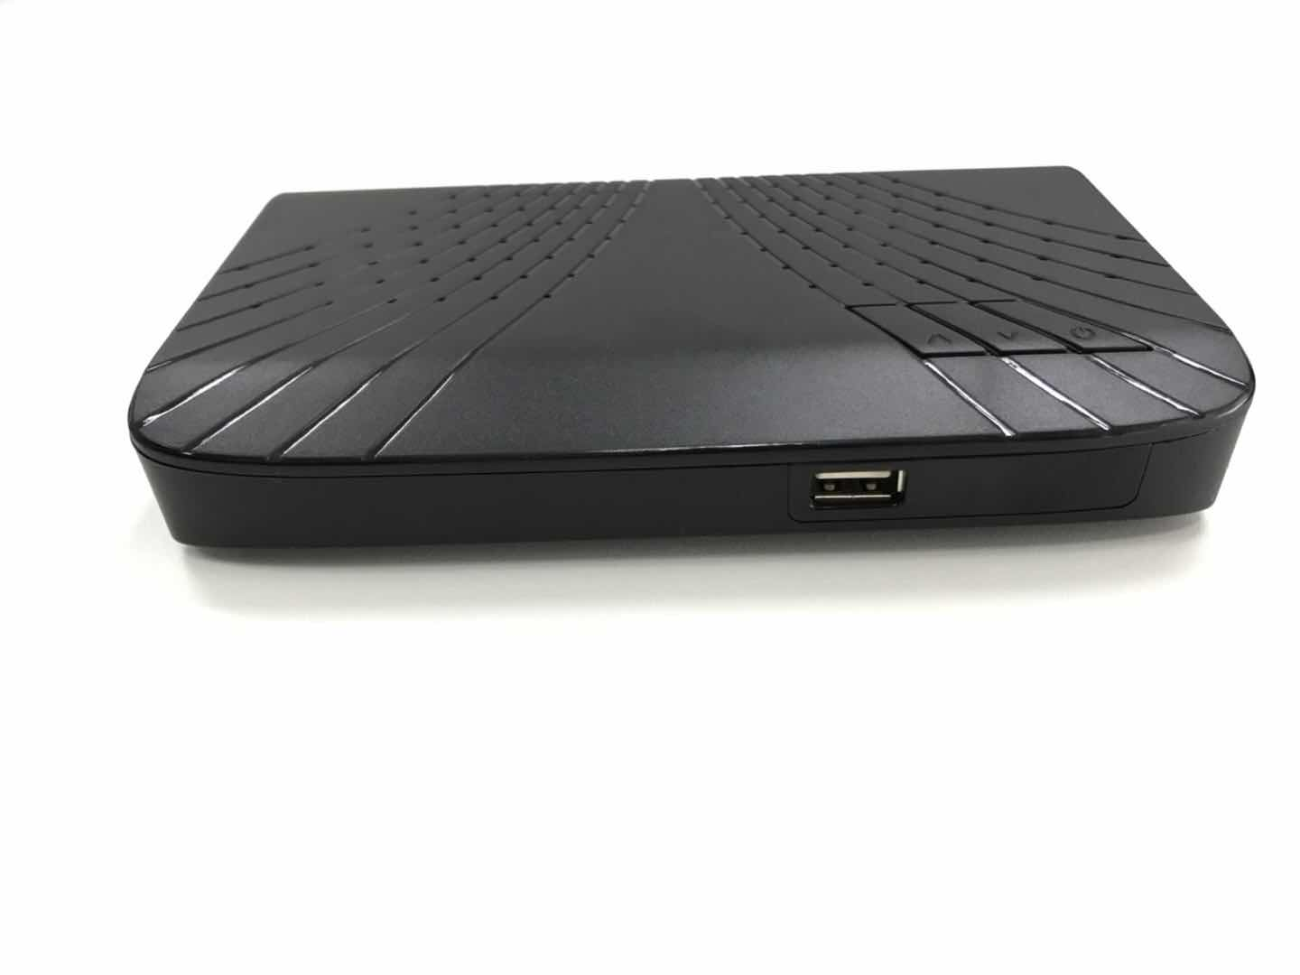

|  |  |
| --- | --- |
| Items | Features |
| IR | 38KHz |
| LED Indicator | Power, Signal |
| Key | 3* Keys (CH+, CH-, Standby) on the topside |
| USB | 1*USB 2.0, Type A |

## 3.7 Back Panel

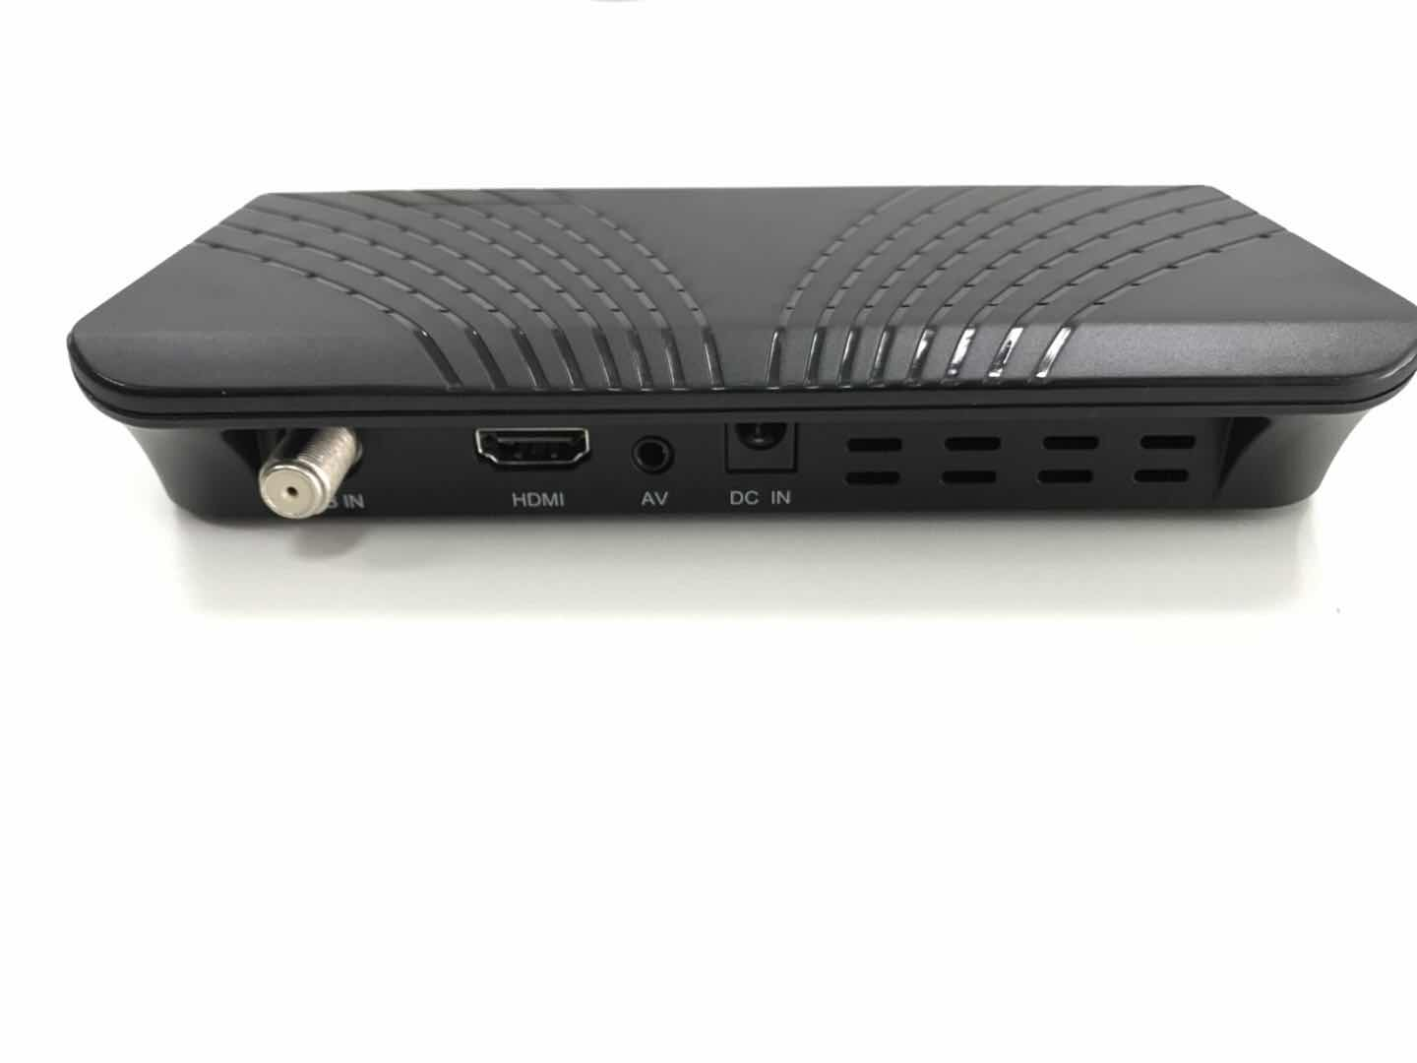

|  |  |
| --- | --- |
| Items | Features |
| RF IN | IEC 60169-24, F-Type, Female |
| AV | 1*3.5mm RCA |
| HDMI | 1*HDMI 1.4 |
| DC IN | 12V DC Adapter |

## 3.8 Remote Control

|  |  |
| --- | --- |
| Items | Features |
| Control Picture |  |
| Key | 45 Keys |
| Battery Type | 2 * 1.5V AAA |

# 4 Power supply

|  |  |
| --- | --- |
| Items | Features |
| DC Input | 12V/1A DC Adapter |
| Supply Mode | External |
| AC Input | 100V~240V |

# 5 Environment

|  |  |
| --- | --- |
| Items | Features |
| Input Voltage | 100V~240V |
| Work Temperature | 0～40℃ |
| Storage Temperature | -20~60℃ |
| Humidity | <95％ |

# 6 Mechanical Features

|  |  |
| --- | --- |
| Items | Features |
| Mechanical Type | plastic case |
| Cover color | Black/white or other |
| Front panel color | Black/white or other |
| Back panel color | Black/white or other |
| Dimension | W: 170 MM, D: 104 MM, H: 30 MM |

# 7 Packing

|  |  |
| --- | --- |
| Items | Features |
| Type | Paper card packaging |
| Outline Size | Customization |
| Gift box | Customization |
| Weight | <1Kg |

# 8 Accessories

|  |  |
| --- | --- |
| Items | Features |
| Power Adapter | 1 *12V/1A DC Adapter |
| HDMI cable | 1 * 1.5m HDMI cable |
| AV cable | 1* 1.5m AV cable |
| Remote control | 1 * Customer Designed Remote Control |
| Battery | 2 * 1.5V AAA |
| User manual | 1* Black White Print Manual |