GYA350 Series 1550nm Fiber Amplifier
GYA350 series Erbium Doped Fiber Amplifier (EDFA) is important 1550nm relay transmission equipment for TV signals, digital video, telephony and data long haul transmission. With well-qualified optical and electronic circuits design, GYA350keeps the excellent optical and electrical performance by using high quality devices. All materials applied in GYA350EDFA meet RoHS requirement.

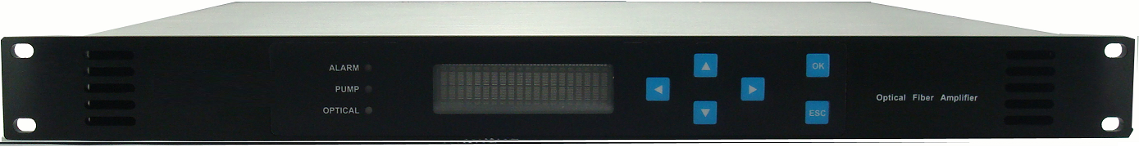

Features
- 19” 1U standard housing with VFD display
- High quality low noise 980nm/1480nm pump lasers
- High quantum efficiency Erbium Doped Fiber
- Built-in microprocessor real time control lasers and the amplifier
- VFD on the front panel displays accurate working parameters
- RS232/RS485 or RJ45 interface available
- 1310nm/1490nm/1550nm WDM port GPON/GEPON optional
- RoHS Compatible

Block Diagram
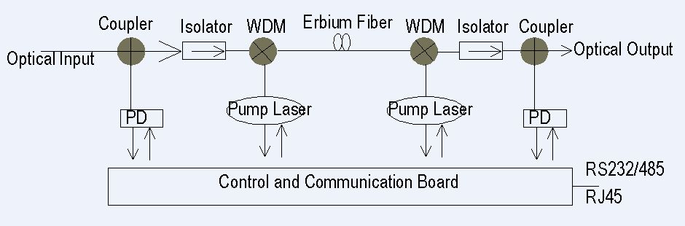

Specifications
Optical Parameter
Wavelength: 1530 ~1565nm
Optical Input Power: -3.0 ~ +10dBm
Saturated Output Power: 14 ~ 23dBm
Optical Return Loss: > 55dB
Pump Laser Wavelength: 980nm or 1480nm
Noise Figure: ≤4.5dB (17dBm)
≤4.7dB (20dBm)
≤5.0dB (22dBm)
≤5.3dB (23dBm)

Power Supply
Power Supply: AC: 100V~240V (50/60 Hz) or -48V DC
Power Consumption: ≤25 W (less than 20dBm), ≤30 W (higher than 20dBm)

Environment
Working Temperature: 0~45ºC
Storage Temperature: -20~65ºC
Humidity: 95% non-condensing

Physical Parameters
Weight: ≤10Kg
Dimensions (mm): 483 × 320 × 44

Customer Interface
RS232/RS485 network interface or RJ45 Ethernet interface
SC/APC or FC/APC fiber connector

Ordering Information
GYA350-A-B-C-D 1550nm optical amplifier in 19” 1RU
A: The optical power in dBm from14dBm up to 23dBm
B: none _1 fiber output, 2_2 fiber outputs, 4_4 fiber outputs
C: FA_FC/APC, SA_SC/APC
D: none _without WDM port, W_with 1310nm/1490nm/1550nm WDM port for PON

