GYA3530 Series 1550nm Fiber Amplifier
With up to 35dBm 1550nm output, GWA3530 series Er-Yb Doped Fiber Amplifiers are important 1550nm relay transmission equipments for High performance supertrunking links, High power distribution networks, Fiber Deep architectures and FTTx networks. GWA3530 Fiber Amplifier is designed to meet the most demanding noise performance requirements of CATV and FTTx applications. GWA3530 fiber amplifier provides optical isolation on the input and output of the gain block for stable, low noise operation. The input and output optical signal power levels are detected for monitoring and control. The input optical signal is amplified with active gain control for a constant output power level, or with active output power control for constant gain mode. GWA3530 series optical amplifiers also provide monitoring functions and associated alarms for all vital characteristics. The optical output of the GWA3530 series optical amplifiers can be split into up to 32 ports by an optional internal splitter.
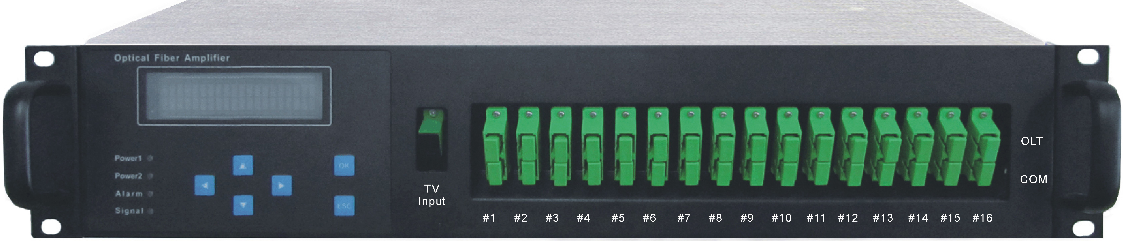
Features
  - High adjustable output power: maximum 35dBm
  - Fiber output supporting multi-ports: 20dBm×N or 17dBm×N
  - Low NF: Typical <5.5dB @+5dBm input
  - Extremely low CSO distortion: < -70dBc
  - Dual CPU dealing with amplifier local controller and remote communication
  - High stability and reliability: MTBF ≥150000 hours
  - Dual Hot-swappable 110V AC or -48V DC Power supplies
  - Ethernet, RS485 and RS232 network interfaces
  - Supporting Telnet and SNMP network management
  - Intelligent temperature control system: Employ special temperature control chip, radiating and power consumption can be reduced 30%
  - Built-in 1310nm,1490nm,1550nm WDM(Optional)
  - RoHS Complied
  - Bellcore GR-1312-CORE Complied

Block and Application Diagram

Specifications
Optical Parameter
Parameter | Symbol | Min | Typ | Max | Unit
Wavelength | λc | 1540 | 1550 | 1565 | nm
Saturated Output Power | Po | 13 | 33 | 35 | dBm
Input Power | Pi | -3 |  | +10 | dBm
Gain | G |  |  | 30 | dB
Noise Figure* | NF |  |  | 6 | dB
Output Power Stability | ΔPo |  | ±0.05 | ±0.2 | dB
Input Isolator | ISOi | 30 |  |  | dB
Output Isolator | ISOo | 30 |  |  | dB
Input Pump Leakage | PumpLin |  |  | -35 | dB
Output Pump Leakage | PumpLout |  |  | -45 | dB
Return Loss | RL |  |  | -45 | dB
Polarization Dependent Gain | PDG |  |  | 0.3 | dB
Polarization Mode Dispersion | PMD |  |  | 0.5 | ps
* Tested at +5dBm optical input

Power Supply
Power Supply: AC: 90V~265V (50/60 Hz) or -48V DC
Power Consumption: ≤50W

Environment
Parameter | Symbol | Min | Typ | Max | Unit
Operating Temperature | Tw | -5 |  | 60 | ℃
Storage Temperature | Ts | -40 |  | 80 | ℃
Humidity |  | 10 |  | 85 | %

Physical Parameters
Weight: ≤20Kg
Dimensions (mm): 483 × 416× 88 (19” 2RU)
Ordering Information
GWA3530-AB-C-D-E-F High Power Fiber Optical Amplifier in 19” 2RU
AB (Output Power): 30_30dBm, 33_33dBm, 35_35dBm
C (Output Ports): 01_1 port, 02_2 ports, 04_4 ports, 08_8 ports, 16_16 ports, 20_20 ports
D (Connector): FA_FC/APC SA_SC/APC
E (Power Supply): Default _single 220V AC, 48_single -48V DC,
AA_Two AC power supplies, DD_Two DC Power supplies;
AD_AC and DC power supplies
F (1310nm/1490nm/1550nm WDM at each fiber output port): Default_None, W_WDM

