GYDFE-500 SMATV RF Fiber Link

Solution Homologated with Tuves HD/DTH

Direct Broadcasting Satellite (DBS) and Direct to Home (DTH) are the most popular way to enjoy satellite TV worldwide. To do it, satellite antenna, coaxial cable, splitter or multi-switcher and satellite receiver are necessary. However, satellite antenna installation might be difficult to the subscribers living in the apartments. SMATV (satellite mater antenna TV) is a good solution for people living in the building or community. With fiber cable, SMATV RF signal can be delivered to 30Km far away or distributed to 32 apartments directly, to 320 or 3200 or 32000 apartments via GY3530 fiber optic amplifier.
GYDFE-500 is a modular 45~2600MHz RF over fiber link, transmitting Terrestrial TV channels and single L-Band RF over one fiber. GYDFE-500 consists of GYDFE-500T transmitter module and GYDFE-500R receiver module. GYDFE-500T transmitter module has one or two RF input ports while GYDFE-500R has one RF output port. With high linearity 1550nm uncooled DFB laser, photodiode and low noise RF gain control circuit, GYDFE-500 can deliver high quality Terrestrial TV channels and satellite RF over fiber to a few subscribers directly or thousands of FTTH subscribers via EDFA. With 1310nm/1490nm/1550nm WDM option, GYDFE-500 can insert L-Band+TV RF over GPON/GEPON. Beside the modular version, GYDFE-500 can have 19”1RU version upon request.
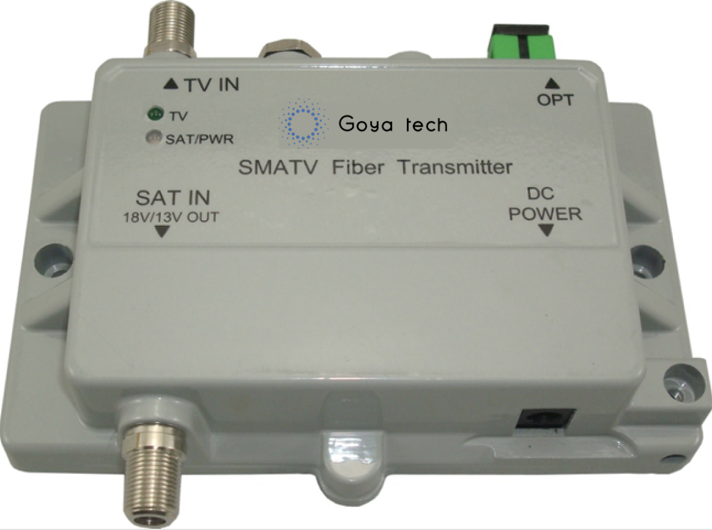
Features:
- Compact aluminum die cast housing
- Single combined RF input with bandwidth:45~2600MHz or
- Two separated RF inputs, including:
One Terrestrial TV input, bandwidth: 174 -806 MHz
One LNB RF input, bandwidth: 950MHz~2150MHz (13V or 18V DC option for LNB on request)
- One RF output port
- High Linearity 1550nm uncooled DFB Laser and Photodiode
- Low noise RF Gain Control circuit
- 19” 1RU housing optional
- 1310nm/1490nm WDM interface for OLT/ONU optional
Specifications:
RF and Optical Characteristics
Parameter | Min | Typ | Max | Unit
Laser Wavelength |  | 1550 |  | nm
Laser Output Power | +1 | +3 | +4 | dBm
Tx Input RF Return Loss | 10 | 12 |  | dB
Tx RF Input Range  20 TV channels equalized at | -55 | -40 | -30 | dBm
Tx RF Input Range  L-Band RF per transponder | -55 | -40 | -30 | dBm
RF AGC Variation | ± 2dB
Frequency Range (L-Band) | 950 - 2150MHz
Frequency Range (Terrestrial TV) | 174 -806 MHz
Flatness | ≤6.0dB in band
Output RF Power at GYDFE-500R | -30±5dBm @Receiver optical Input -10dBm
IMD 2nd order | L-Band: ≥32dB (two input tones at -20 dBm)  Terrestrial TV: ≥50dB (two input tones at -20 dBm)
IMD 3RD order | ≥53dB (two input tones at -20 dBm)

RF/Optical Interface
RF Connector | F-Type
RF Impedance | 75 Ohm
Fiber | 9μm / 125μm Single Mode Fiber
Fiber Connector | SC/APC, SC/UPC, FC/APC, FC/UPC

Physical and Environmental Characteristics
Power Supply | 12V 1A DC adaptor (no LNB power request)  19V 1A DC adaptor (on LNB power request)  100~240V AC (19” 1RU version)
Power Consumption | < 3W (for single Tx module or Rx module)
Dimension (for single module) | 127mm×90mm×30mm (19” 1RU on request)
Weight (for single module) | 0.5Kg (without power adaptor)
Operating Temperature | -10~+50℃
Storage Temperature | -40~+85℃
Relative Humidity | 5~95 % (non-condensing)

Ordering Information
GYDFE-500T-X-Y-Z Terrestrial TV and L-Band RF fiber optic transmitter
X (RF Input): T_Terrestrial TV input only; B_ LNB input only
C_ Combined Terrestrial TV and LNB RF at one RF port
D_ Dual RF inputs, one for Terrestrial TV and one for LNB RF
Y (Fiber Connector): SA_SC/APC, SU_SC/UPC, FA_FC/APC, FU_FC/UPC
Z (LNB power voltage at LNB RF input port): None_No power to LNB, 13_13V DC, 18_18V DC

GYDFE-500R-Z Terrestrial TV and L-Band RF fiber optic receiver
Z (Power Supply): None_No power adaptor or powered by satellite receiver, 12_12V DC

