GYDFH-100 FTTH Sat TV Optical Receiver with WDM
Solution Homologated with Tuves HD/DTH

GYDFH-100 is 1550nm satellite TV RF FTTH optical receiver with 1310nm/1490nm GPON WDM (upgradable to 1270nm/1577nm supporting XGPON ONU), receiving 1550nm Terrestrial TV and Sat RF optical signal from Passive Optical Network (PON) while passing 1310nm/1490nm or 1270nm/1577nm digital signals to ONU device. Working with GOYATECH dCSS satellite TV fiber optic transmitter or 1550nm fiber optic transmitter, GYDFH-100outputs high quality terrestrial TV and satellite TV RF.
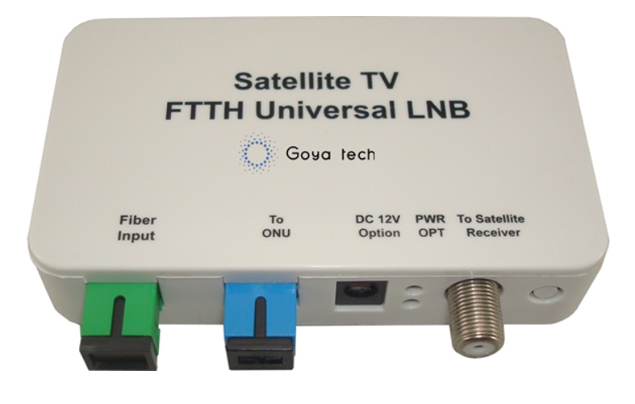

Features:
- Compact plastic flame retarding housing
- High Linearity Photodiode for Terrestrial TV and Satellite TV RF
- 88MHz~2350MHz (downstream) RF Output
- Optical AGC range: -10dBm ~ -2dBm
- 1310nm/1490nm Optical Bypass Port to ONU
- WDM can be upgraded to include 1270nm/1577nm reflection port for XGPON ONU
- DC Power and optical input LED indicator
- 12V DC power adapter
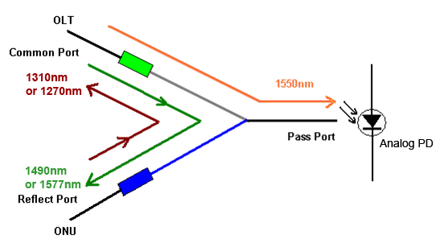
Specifications
Item | Parameter
Input Optical Wavelength | 1540~1565 nm
Reflecting Channel Wavelength | 1260nm~1360nm and 1480nm~1500nm
Working Optical Power | -14dBm ~ -2dBm@1550nm
Optical Connector | SC/APC
Optical Return Loss | 45 dB
RF Bandwidth | 88 ~ 2350 MHz
RF Flatness | ± 4.0dB
RF Return Loss | >10 dB
Satellite User Bands | 32 (typical)
Each User Band bandwidth | 36MHz (typical)
RF Connector | American F Female
RF Output Impedance | 75Ω
AGC Range | -10dBm ~ -2dBm Optical Input
RF Output Level | >74dBμV @ (-10dBm~-2dBm)
Output to ONU
Loss at 1310nm/1490nm | <0.8dB
Isolation (Com-Pass at 1310nm) | > 35dB
Isolation (Com-Pass at 1490nm) | > 35dB
Isolation (Com-Reflect at 1550nm) | > 18dB
Output Connector | SC/UPC
Optical Return Loss | >45dB
Environment
Power Supply | 12 V 0.5mA (UL or CE approved)
Power Consumption | <2W (not including power adapter)
Working Temperature | -10 ~ +50℃
Board Dimension (L*W*H) | 106mm×62mm×25mm
Weight (without power adapter) | 200g

Ordering Information
GYDFH-100-KX FTTH Satellite RF Optical Receiver with WDM
X(WDM Option): None_GPON WDM only, X_ both GPON and XGPON WDM

=

