GYR1200 Universal Optical Node

GYR1200 Optical Node has universal die-cast aluminum housing outputting forward path analog TV, DVB-C and CMTS DS signals and sending upstream cable modem signals at regular or burst mode over the single Bi-directional fiber or the 2nd fiber. The forward path RF output can be 108dBµV/112 dBµV, single port or dual ports, 1005MHz or 1218MHz forward path bandwidth. GYR1200 can support DOCSIS2.0, DOCSIS3.0 or DOCSIS3.1.
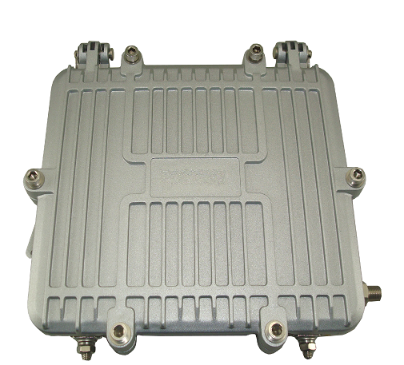

Features:
- Aluminum Die Cast Universal Housing
- Two fibers or Single fiber bi-directional optical transmission
- 1005MHz or 1218MHz forward path RF bandwidth
- Single or Dual 108dBµV/112 dBµV Forward RF outputs
- Forward Path 15dB Slop and 15dB attenuator
- AGC effective at -5dBm~+1dBm optical input
- 5~85MHz/204MHz return RF bandwidth option
- Up to 16 CWDM DFB laser wavelength working at burst mode
- 4KV Surge Protection
- 60V or 220V power supply

Specifications
Item | Parameter
Forward Path Receiver
Forward RF Optical Wavelength | 1540~1560 nm
Working Optical Input Power | -7dBm ~ +2dBm
Optical AGC range | -5dBm ~ +1dBm
Forward Optical Power Test Point | 1V/mW
Fiber Input Connector | SC/APC
Optical Return Loss | 50 dB
RF Output Ports | 1 or 2
RF Output Level | 108 dBµV or 112dBuV
RF Diplexer | 85/110MHz or 204/258MHz
RF Slop | 0~15dB adjustable
RF Attenuator | 0~15dB adjustable
RF Connector | American F
RF Output Impedance | 75Ω
Surge Protection at RF port | 4KV
RF Flatness | ± 1.5 dB (0dB Slop or after 15dB slop cable)
RF Return Loss | >16 dB
CNR | >44 dB @ -5dBm
CSO | <-60 dBc @77ch NTSC@0dBm
CTB | <-60 dBc @77ch NTSC@0dBm
Return Path Transmitter
Return Path Laser Wavelength | 1270nm, 1290nm, 1310nm, 1330nm, 1350nm, 1370nm, 1390nm, 1410nm, 1430nm, 1450nm, 1470nm, 1490nm, 1510mm,1530nm, 1590nm, 1610nm
Optical Output Power | 3±1 dBm
Laser Power Test Point | 1V/mW
Optical Indicator ON | >-3dBm
Return Path Laser off power | <-30dBm
Return Laser Rise/Fall Time | <1.5μs as defined by SCTE-174-2010
Return RF Bandwidth | 5~85MHz/204MHz (5~30MHz filter on request)
Return RF Input Level | 17dBmV
Return RF Return Loss | 16dB
Return RF Flatness | ± 0.75 dB
Environment
Working Temperature | -20 ~ +55℃
Storage Temperature | -40 ~ +85℃
Power Supply | 60V or 220V AC
Power Consumption | 15~30W
Dimension (L*W*H) | 173mm×149mm×41mm
Weight | 3Kg

Ordering Information
GYR1200 -ABCDEFG Fiber to the Building two-way optical Node
A (RF Output Port): 1_1 RF output, 2_2 RF outputs
B (Forward Bandwidth): 1_1005MH z, 2_1218MHz
C (Frequency Duplexer): 1_85/110MHz, 2_204/258MHz
D (RF Output Level): 1_108 dBµV, 2_112 dBµV
E (Fiber Port): 1_Single fiber bi-direction 2_2 separate fibers
F (Burst Mode): 1_No Burst Mode, 2_Burst Mode
G (CWDM wavelength): 29_1290nm, 31_1310nm, 33_1330nm, 35_1350nm, 37_1370nm
39_1390nm, 41_1410nm, 43_1430nm, 45_1450nm, 47_1470nm
49_1490nm, 61_1610nm
H (Power Supply) 60_60V AC, 220_220V AC

