GYR3300 Return Path Optical Receiver
GYR3300 rack mount return path receiver is designed for the indoor CATV return signal receiving. In the 19” 1RU rack, there are maximum 4 independent return path optical receivers. With high performance photodiode and hybrid amplifier, GYR3300 offers a clean return path band for Cable Modem up-streaming signals. Optical power indicator and RF test port on the front panel can indicate receiver’s status.
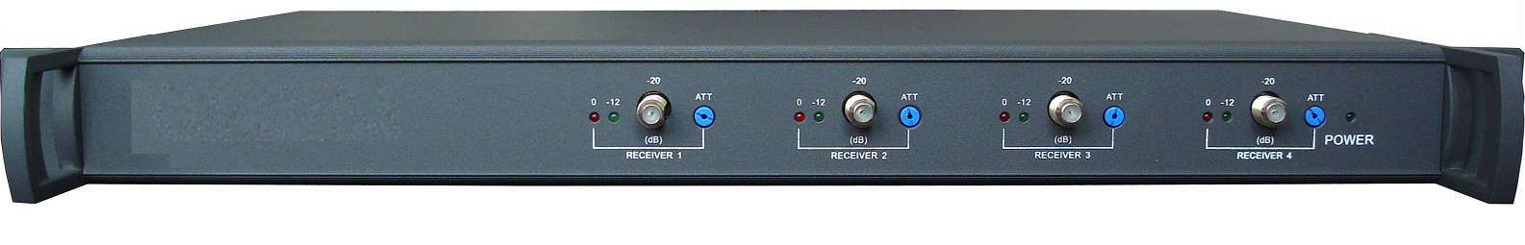

Features
- 1550nm/1310nm dual wavelength
- 4 independent RPR in one 19” 1U standard rack
- Low noise, high linearity photodiode
- 5- 204 MHz RF Bandwidth
- Two band pass filters to depress the upstreaming noise
- Output adjustment and -20dB RF test available on front panel

Block Diagram

Specifications:
Items | Unit | Technical Parameters
Input Optical Power | dBm | -15 ~ +2
Recommended Optical Input | dBm | -10 ~ 0
Optical Return Loss | dB | >45
Optical Wavelength | nm | 1100 ~ 1650
Optical Fiber Connector |  | FC/APC or SC/APC
Noise Power Ratio | dB | ≥ 15 (for DFB laser return path transmitter)
Noise Power Ratio | dB | ≥ 10 (for FP laser return path transmitter)
Frequency range | MHz | 5~204
Flatness in band | dB | ±0.75
RF Output Level | dBmV | 20@-8dBm optical input
MGC Control Range | dB | 0~20
RF Return Loss | dB | ≥16
Output Impedance | Ω | 75
Working Temperature | ˚C | -10~+55
Power consumption | W | 18
Power Supply | V | 90~265 (50/60Hz)
Dimensions | mm | 480×325×44
Weight | Kg | 5

Ordering Information

GYR3300-A-BC 19” 1U Optical Return Path Receiver
A: Number of independent optical return path receiver, from 1 to 4
BC: FC for FC/APC connector
SC for SC/APC connector

