GTY350C 1550nm DFB Transmitter
GTY350C is a direct modulation 1550nm DFB transmitter for analog TV, digital TV and CMTS signals local fiber dense distribution and QAM TV Signal long-distance fiber transmission. The transmitter utilizes high linearity DFB laser, RF power digital automatic process technique, along with RF pre-distortion circuit developed by GOYA Technology. The built-in microprocessor monitors the transmitter working status and automatically ensures the optimistic performance. GTY350C is ideal for analog TV fiber distribution within 20Km and QAM TV signal long distance transmission within 100Km.
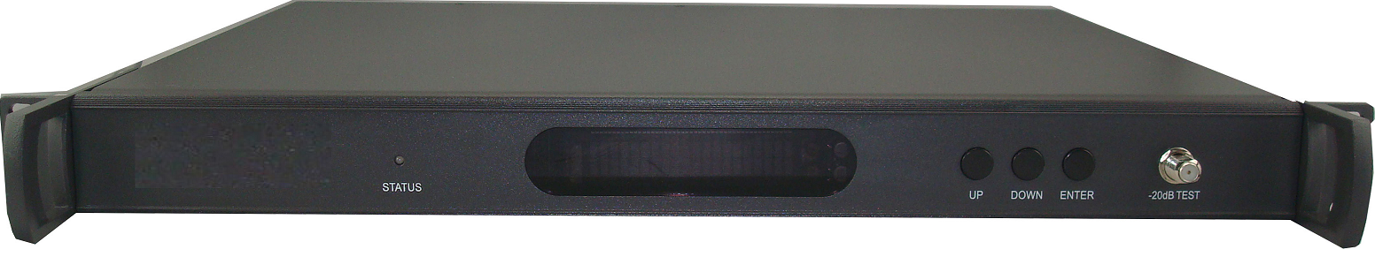

Features
- Low noise high linearity Ortel-Emcore cooled DWDM DFB laser
- GaN Technology up to 1218MHz
- RF power digital automatic process technology control the laser driving RF power level automatically according to RF signal level and channels, ensuring the best C/N, CTB and CSO
- Excellent pre-distortion technology improves CTB, CSO and C/N
- Built-in microprocessor accurately monitors laser output power and temperature.
- Front panel VFD displays the status parameters and function message
- SNMP network management optional

Block Diagram

Specifications
Item | Unit | Parameter
Optical Power | mW | 10
Optical Link Path Loss | dB | 11
DWDM Wavelength | nm | 1528~1563nm ITUT Cxx channel
Type of Laser |  | 14pin cooled DFB laser in butterfly package with isolator
Optical modulation mode |  | Direct Modulation
Optical connector Type |  | SC/APC or FC/APC
Frequency Range | MHz | 47~1000/1218
RF Input Level | dBmV | 15~25
Flatness In Band | dB | ±0.75
RF Input Impedance | Ω | 75
Input Reflection Loss | dB | ≥16
C/CTB | dB | ≥65
C/CSO | dB | ≥59
C/N | dB | ≥51
AGC Control Range | dB | 0~15
MGC Control Range | dB | 0~15
Power Voltage | V | AC 100V~240V （50/60 Hz）
Power Consumption | W | 15
Operation Temperature | °C | 0~50
Store Temperature | °C | -40~85
Relative Humidity | % | Max 95% no condensation
Dimension | mm | 483 (L) × 381 (W) × 44 (H)
Weight | Kg | 5
Test condition：Input 59 channels PAL-D signal to the optical transmitter and measure the standard optical receiver C/CTB, C/CSO and C/N in conditions of -1dBm optical input (10km fiber + optical attenuator) and 36 dBmV RF output.

Ordering Information:

GTY350C-AB-CD-E Forward Path 1550nm Direct Modulation Transmitter
AB: Optical output power in mW, 10mW only
CD: Optical connector, FC_FC/APC, SC_SC/APC
E: None for RS-232 interface, N for SNMP interface
