S2002-B

Set Top Box Specification

**Document Record**

|  |  |
| --- | --- |
| **DOCUMENT NUMBER** | **CONFIDENTIALITY LEVEL** |
| **GX6616-20211223** | **HIGH** |
| **DOCUMENT VERSION** | **TOTAL 9** |
| **V1.0** |

**Revision Record**

|  |  |  |  |  |
| --- | --- | --- | --- | --- |
| **DATE** | **VERSION** | **DESCRIPTION** | **AUTHOR** | **APPROVED** |
| **2021/12/23** | **V1.0** | **INITIAL RELEASE** | **Yuelong Gu** | **Hong Li** |

CONTENT

1 Production Introduction 3

1.1 Scope 3

1.2 Abbreviations and Acronyms 3

3 Hardware Specification 4

3.1 Chipset 4

3.2 Tuner 4

3.3 Demodulator 4

3.4 Video Decode 5

3.5 Audio Decode 5

3.6 Interface 5

3.7 Remote Control 6

4 Power supply 6

5 Environment 6

6 Mechanical Features 7

7 Packing 7

8 Accessories 7

# 1 Production Introduction

## 1.1 Scope

The GOYATECH S2002-B HD Set-top Box (STB) offers subscribers the latest enhancements in satellite television viewing. This STB gives consumers a rich experience with new features which provides customize design solution and a variety of applications such as 7 days EPG, genres navigators and many other utility services.

The S2002-B compliant with DVB-S/S2 standards and MPEG-2/MPEG-4. It supports PAL/NTSC formats with its CAS, it is built to support renewable security. The main features of this STB described as below:

* Support Sumavision advanced security CAS
* Video decoder support MPEG-2/MPEG-4, H.264
* Audio decoder support MPEG-1 I/II, AAC, HE-AAC

## 1.2 Abbreviations and Acronyms

|  |  |
| --- | --- |
| Items | Description |
| STB | Set Top Box |
| EPG | Electronic Program Guide |
| DDR | Double Data Rate |
| HD | High Definition |
| OSD | On Screen Display |
| RAM | Random Access Memory |
| RF | Radio Frequency |
| DVB | Digital Video Broadcasting |
| SD | Standard Definition |
| CA | Conditional Access |
| LED | Light-emitting Diode |
| PAL | Phase Alteration Line |
| CVBS | Composite Video Blanking Signal |
| IR | Infra-Red |
| MPEG | Moving Pictures Expert Group MPEG |
| QAM | Quadrature Amplitude Modulation |
| MP@ML | MPEG Main Profile at Main Level |



# 3 Hardware Specification

## 3.1 Chipset

|  |  |
| --- | --- |
| Items | Features |
| Main Chipset | GX6616 |
| SDRAM Memory | 128Mbyte |
| Flash Memory | 16MByte |

## 3.2 Tuner

|  |  |
| --- | --- |
| Items | Features |
| Tuner Type | DVB-S/S2 |
| Frequency Range | 950~2150MHz |
| Input Impedance | 75Ω |
| Signal input | IEC 60169-24 F-Type, Female |

## 3.3 Demodulator

|  |  |
| --- | --- |
| Items | Features |
| Multi standard demodulation & decoding | -DVB-S2 CCM  QPSK+1/4, 1/3, 2/5, 1/2, 3/5, 2/3, 3/4, 4/5, 5/6, 8/9, 9/10  8PSK+3/5, 2/3, 3/4, 5/6, 8/9, 9/10  16APSK+2/3, 3/4, 4/5, 5/6, 8/9, 9/10  32APSK+3/4, 4/5, 5/6, 8/9, 9/10  - Legacy DVB-S  QPSK+1/2, 2/3, 3/4, 5/6, 7/8 |
| Other | VCM mode supported  Automatic standard recognition  Support 1 to 60Mbaud symbol rates  Fast channel blind scan for RF frequency & symbol rate acquisition |

## 3.4 Video Decode

|  |  |
| --- | --- |
| Items | Features |
| Video Decode | H.264 video BP/MP/HP up to L4.1;  MPEG-4 video SP/ASP up to L5;  MPEG-2 video MP@HL |
| Aspect Ratio | 4:3, 16:9 |
| Video Resolution | Up to 1080p |
| Video Format | PAL/NTSC |

## 3.5 Audio Decode

|  |  |
| --- | --- |
| Items | Features |
| Audio Decode | MPEG-1 I/II, AAC, HE-AAC decoding |
| Output | Stereo/Mix/Right/Left |
| Sampling Frequency | 32KHz, 44.1KHz, 48KH |

## 3.6 Interface

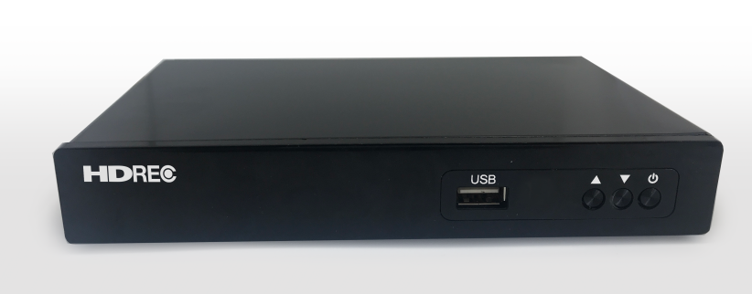

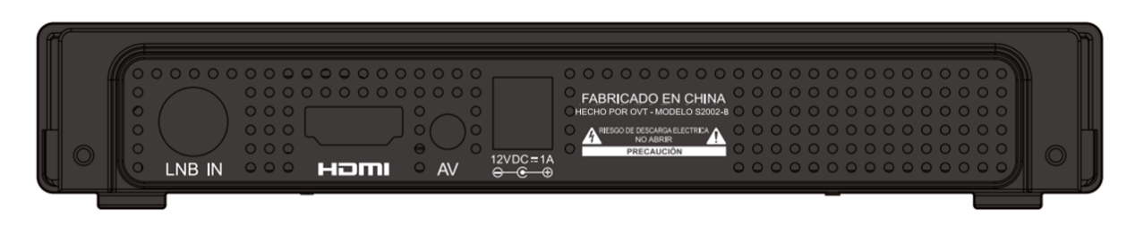

|  |  |
| --- | --- |
| Items | Features |
| IR | 38KHz |
| LED Indicator | Power, Standby |
| KEY | 3* Keys (Standby, CH-, CH+) |
| USB | 1*USB 2.0, Type A |
| LNB IN | IEC 60169-24, F-Type, Female |
| AV | 1*3.5mm Jack |
| HDMI | 1*HDMI 1.4 |
| DC 12V1.0A | 12V DC Adapter |

## 3.7 Remote Control

|  |  |
| --- | --- |
| Items | Features |
| Control Picture |  |
| Key | 45 Keys |
| Battery Type | 2 * 1.5V AAA |

# 4 Power supply

|  |  |
| --- | --- |
| Items | Features |
| DC Input | 12V/1A DC Adapter |
| Supply Mode | External |
| Power Consumption | 10W MAX |

# 5 Environment

|  |  |
| --- | --- |
| Items | Features |
| Work Temperature | 0～40℃ |
| Storage Temperature | -20~60℃ |
| Humidity | <95％ |

# 6 Mechanical Features

|  |  |
| --- | --- |
| Items | Features |
| Mechanical Type | Cover metal , Bottom plastic |
| Cover color | Black |
| Front panel color | Black |
| Back panel color | Black |
| Dimension | W: 170 MM, D: 100 MM, H: 27 MM |
| Weight | 169g |

# 7 Packing

|  |  |
| --- | --- |
| Items | Features |
| Type | Paper card packaging |
| Outline Size | Customization |
| Gift box | Customization |
| Weight | TBD |

# 8 Accessories

|  |  |
| --- | --- |
| Items | Features |
| Power Adapter | 1 *12V/1A DC Adapter |
| HDMI cable | 1 * 1.5m HDMI Cable |
| AV Cable | 1*1.5m AV Cable |
| Remote control | 1 * Customer Designed Remote Control |
| Battery | 2 * 1.5V AAA |
| User manual | 1* Black White Print Manual |